**AKENTEN APPIAH-MENKA UNIVERSITY OF SKILLS TRAINING AND ENTREPRENEURIAL DEVELOPMENT.**



**FACULTY OF APPLIED SCIENCE AND MATHEMATICS EDUCATION**

**DEPARTMENT OF INFORMATION TECHNOLOGY EDUCATION**

**AAMUSTED TIMETABLE SCHEDULER**

**A PROJECT SUBMITTED TO THE DEPARTMENT OF INFORMATION TECHNOLOGY EDUCATION IN PARTIAL FULFILMENT OF THE REQUIREMENT FOR THE AWARD OF BACHELOR OF SCIENCE DEGREE IN INFORMATION TECHNOLOGY EDUCATION**

**BY:**

|  |  |
| --- | --- |
| **INDEX NUMBER** | **NAME** |
| **5181040189** | **NYA MAAH FRIMPONG EMMANUEL** |
| **5181040337** | **BLESSIE DAVID** |
| **5181040369** | **DIVINE YEBOAH OBENG-MFRAMA** |
| **5181040334** | **PETER HENRY BERNASCO** |

**SUPERVISOR: DR. CALEB JOSHUA DAGADU**

**DECLARATION**

**STUDENT’S DECLARATION**

We hereby declare that this project work with the exception of quotations and references contained in published works which have all been acknowledged, is the result of our original research and that no part of it has been presented for another degree in this university or elsewhere.

SIGNATURE.............................................. INDEX NUMBER....................................................

SIGNATURE.............................................. INDEX NUMBER....................................................

SIGNATURE.............................................. INDEX NUMBER....................................................

SIGNATURE.............................................. INDEX NUMBER....................................................

**SUPERVISOR’S DECLARATION**

I hereby declare that the preparation and supervised in accordance with guidelines on supervision of project works laid down by the Akenten Appiah-Menka University of Skills Training and Entrepreneurial Development.

SIGNATURE...................................................... DATE................................................................

**DR. CALEB JOSHUA DAGADU**

**ACKNOWLEDMENT**

This research project would not be successful without the support and sacrifice of others. We are most grateful to Almighty God for his guidance and protection throughout our stay on campus and seeing us to a successful end of the program and the accomplishment of this work.

We also owe a debt of gratitude to our supervisor, DR. CALEB JOSHUA DAGADU, for his constant encouragement and patience during the preparation of this work. He spent his precious time reading and correcting the entire manuscript and also offering suggestions for the success and completion of this work. Sir, we really appreciate your objective criticisms and unique way of guidance which helped us minimize the challenges we encountered in the cause of producing this work. As a matter of fact, we enjoyed working under your supervision. God bless you abundantly. We will always remember you.

We also express our sincere appreciation to all the lecturers at the Information Technology Education department, our family members, and all our good friends for their support in diverse ways.

God richly bless you all.

**ABSTRACT**

**The main purpose of the project was to develop a timetable scheduler system which will enable the academic office of Akenten Appiah Menka University of Skills Training and Entrepreneurial Development to schedule lecture timetables. To develop this system, the project team gathered user specifications which formulated the specific objectives of the project. These objectives served as the parameter around which the system was going to function.**

The tools that were used for the design and development of the system are Apache NetBeans, which embodies Java language and CSS for the designing of the interface and interactivity. We also employed the use of MongoDB to handle the database aspect of the system. The testing was done with the use of the black box methodology with all functional and non-functional requirements catered for. The developed system does not only generates timetable but also generates timetable that does not clash**. The general outputs of the new system are indeed useful to both students and lecturers of the university as it provides a life-solution to the present problem.** In the future, we recommend that further development or addition to the system should include features where **students and lecturers get a copy of the scheduled timetable through email service, cloud storage of generated timetables and other important data needed in generating timetables.**

**TABLE OF CONTENT**

**TITLE PAGE i**

**DECLARATION ii**

**ACKNOWLEDGEMENT iii**

**ABSTRACT iv**

**TABLE OF CONTENTS v**

**LIST OF TABLES viii**

**LIST OF FIGURES ix**

CHAPTER ONE 1

INTRODUCTION 1

1.1 Background of Study 2

1.2 Problem Statement 4

1.3 Aims and Objectives of the Project 5

1.4 Significance of the Project 5

1.5 Scope and Limitations of the Project 6

1.6 Organisation of the Project Report 6

1.7 Chapter summary 7

CHAPTER TWO 8

LITERATURE REVIEW 6

2.1 Chapter Introduction 6

2.2 Conceptual and Theoritical Review 9

2.3 Existing Systems Review 13

2.4 Chapter Summary 15

CHAPTER THREE 16

METHODOLOGY 16

3.1 Chapter Introduction 14

3.2 Research Design 17

3.3 Research setting 20

3.4 Data Collection Instrument 21

3.5 Ethical Consideration 22

3.6 Description of the Proposed System 23

3.7 System Development 23

3.8 System Development Life Cycle 25

3.9 Chapter Summary 35

CHAPTER FOUR 36

SYSTEM DEMONSTRATION AND EVALUATION 36

4.1 Chapter Introduction 36

4.2 System Demonstration 36

4.3 System Evaluation 39

4.4 Chapter Summary 49

CHAPTER 5 50

SUMMARY, CONCLUSION AND RECOMMENDATIONS 50

5.1 Chapter Introduction 50

5.2 Summary 50

5.3 Conclusion 50

5.4 Recommendations 51

5.5 Chapter Summary 51

REFERENCE 52

APPENDICES 54

**LIST OF TABLES**

Table 4.1 Test case used in the Integration Testing 1

Table 4.2 Functional Testing 2

Table 4.3 Non-Functional Testing 3

**LIST OF FIGURES**

figure 1.1 An interface of Auto time-table generator………………………………………………1

Figure 1.2Automated college timetable generator……………………………………………...…2

Figure 3.1 general Overview 3

Figure 3.2 System Flowchart 4

Figure 3.3 System Use Activity Diagram 5

Figure 3.4 High-level system Architecture diagram 6

Figure 3.5 System Use case diagram 7

Figure 3.6 Sytem Sequence Diagram 8

Figure 3.7 System class diagram…………………………………………………………………9

Figure 3.8 System E-R diagram………………………………………………………………….10

Figure 4.1 11

Figure 4.2 12

Figure 4.3 13

Figure 4.4 14

Figure 4.5 15

Figure 4.6 16

Figure 4.7 17

Figure 4.8 18

Figure 4.9 19

**CHAPTER ONE**

**INTRODUCTION**

Education has come of age and the way school management and authorities run school administration and other school affairs is gradually changing in Ghana. First, everything was done manually but now, a lot of tasks has being automated for quick and easy execution. The timetable generation system should not be left out when this success story of using automated systems in our educational sector is mentioned.

A lecture timetable generator is a system of allotting lecture time and resources at hand to make better use of the available resources. *“It is one of the most important yet time-consuming tasks done periodically in any academic institution of learning.” Jumoke Soyemi, John Akinode, Samson Oloruntoba (August 5, 2017).*

Creating a course timetable in the university or school with a large number of courses, teachers, and students is a tedious task that anyone can undertake. Mostly this is done manually but it has never been easy for the people responsible for this task. Sometimes, the administrative workers responsible for generating course timetable spends a lot of productive time on getting a working timetable for the school that is free of challenges but after spending much time generating this timetable, it comes out with a lot of challenges. Schools that have a fixed number of teachers, courses, and student population do not have many challenges in generating timetables but this is different when it comes to tertiary education. Student population, number of programs with their various courses, number of lecturers, and lecture halls among other things are the issues that give lots of challenges when generating timetables.

Having a carefully planned and developed timetable generator system which will consider all these important elements in generating a timetable will go a long way to avoiding important challenges posed by the manual system. This will help in generating successfully a working course timetable on time. This system will help all the departments of AAMUSTED to generate course timetables on time free from clashes. Something which could take several days to do but still have some classes clashing can now be done easily and on time. With this timetable generator that we are proposing, what has been a challenging task will become a thing of the past.

**1.1 BACKGROUND OF THE STUDY**

Task and time allotment is one of the important administrative activities that goes on in the universities and this task does not come any easier. Scheduling a timetable is one of this administrative activity and it is very stressful due to different factors which needs to be considered before and during timetable scheduling. In generating a course timetable for universities, many constraints need to be fulfilled if you want to have a timetable free from clashes and other challenges.

Before we go deeper let’s look at what a timetable means, “timetable is the allocation of subject to constraints of given objects being in space-time in such a way as to satisfy as nearly as possible a set of desirable objectives”, Wren A. (1995).

Looking at the definition of timetable given by Wren A. (1995), we realized a timetable has a lot of factors or constraints to consider when scheduling one. These constraints can be categorized into two major groups thus;

Hard constraint.

Soft constraint.

“Soft and hard constraints are the fundamental elements behind not only creating a great timetable but also a working one”, Ben Moreland (April 21, 2015).

For us to be able to develop a working and a great timetable, these constraints must be considered. The hard constraints are made up of the fundamental elements of a timetable and these constraints must be adhered to when developing the timetable generator. Some examples of hard constraints are:

1. Number of teaching spaces
2. The teaching week
3. Number of weeks in the semester
4. Student clash checks
5. Teaching room capacity

These hard constraints must be adhered to if one needs a working timetable since the timetable is developed around these principles

Some examples of soft constraints include:

1. Student lunch hour
2. Student teaching day
3. Teaching space capacity
4. Gap between lectures
5. Staff consecutive teaching hours
6. Staff teaching week.

Adhering to soft constraints will not only get you a working timetable but also a great timetable. Course timetable scheduling has no single or an exact way of doing it because the data involved may vary from time to time and from place to place. And also depends on what one is looking forward to achieving and what resources are available.

“Creating a perfect timetable is a challenge as we must balance the competing needs of students, teachers, and subjects”. “Timetabling is an incredibly important job; it is one of those integral pieces of work that ensures that school operates successfully on daily bases”, Diary of a Head teacher (June 21st. 2017).

Due to the complexness of this challenge, timetable coordinators pay much attention to time trying to find the most effective way. However, although they have lots of expertise, the resolution found might not be effective thanks to the number of available options. Thus, the distribution of work among the various lecturers in an educational establishment constitutes the challenges of combinatorial nature. In general, a resolution of such challenges and obtaining precise optimum solutions is computationally difficult.

There are some existing timetable generators but most of these do not consider the basic elements of timetable scheduling and they end up generating timetables with lots of challenges just as in the manual system. Carefully planning and developing a system based on the correct algorithm, constraint, resources, and data available will help eradicate most of these challenges and this is exactly what we are proposing to do in our research project.

**1.2 PROBLEM STATEMENT**

There cannot be a solution without a problem. Course timetable scheduling has been a stressful task for many administrative workers due to the level of logic involved in getting it accurate. A lot of productive time is spent on scheduling a timetable to run a semester successfully. “There is a certain skill-set that is required to complete a school timetable. You need to be a logical thinker and enjoy problem-solving, while at the same time having the ability to be creative, flexible, and think outside the box – necessities to overcoming the complicated nature of compiling a whole-school timetable”, Diary of a Head teacher (June 21st. 2017).

“*Scheduling is one of the problems which so many researches have been conducted on it over the years. The university course timetabling problem which is an NP-hard problem is a type of scheduling problem.” Hamed Babei, Jabaer Karimpour, Amin Hadidi – Computers and Industrial Engineering 86, 43-59(2015).*

NP-hard problem is a nondeterministic polynomial-time problem. A problem, therefore, is considered NP-hard if it can be related to an NP-hard problem. Timetable scheduling is considered an NP-hard problem due to the complexities involved in the algorithms used to derive a working timetable. The constraints to be considered in generating a working timetable are a lot. These factors make it a Non-Polynomial –hard Problem thus it has no particular working solution. Therefore careful planning and the right algorithm must be used to arrive at a great timetable and this is what is lacking in the manual and the automated timetabling system already in use. Of this, a lot of conflicting schedules exist on the timetable which in turn cause irregularities and clashes.

“The timetabling problem is common to academic institutions such as schools, colleges, or universities. It is a very hard combinatorial optimization problem that attracts many researchers’ interest.” MC Chen, SL Goh, [NR Sabar](https://scholar.google.com/citations?user=0yWrqXAAAAAJ&hl=en&oi=sra), [G Kendall](https://scholar.google.com/citations?user=VjJm3zYAAAAJ&hl=en&oi=sra) - IEEE Access (2021).

A lot of people lack this set of skills to schedule timetables and hence end up ignoring the basic principle that will help schedule a working and a great timetable. And when this happens,

1. A lot of time is spent on scheduling a timetable
2. Clashes occur in class allocation
3. It is difficult to remove clash from the timetable
4. A lot of resources are needed to get a working timetable.

Though each university has its peculiar problem when it comes to timetable scheduling the above problems cut across and these challenges need to be addressed.

**1.3 AIMS AND OBJECTIVES**

**Aims**

A lot of resources go into timetable scheduling and mostly after spending many resources to get a working timetable, it ends up not being used or contains many challenges that may render the timetable useless or problematic. Our main aim of this project is to create an automated system using the right algorithm that can automatically generate a working and a great timetable for AAMUSTED to solve the problems posed by manually generating a timetable or using an existing timetable generating system that cannot give an accurate timetable.

**Objectives**

Our objectives are to develop an automated timetable generating system.

1. To solve the problem of clashing classes
2. To solve the long time spent in generating a timetable manually
3. Use the right algorithm to generate a more simple and efficient timetable automatically.

**1.4 SIGNIFICANCE OF THE PROJECT**

This project is an important project which needs a lot of research effort as a matter of agency to solve misunderstanding that frequently occurs as a result of allocating one lecture hall to different courses. When we came to level 100 to level 300, I could remember there was no single semester that we did not have a conflict with other classes due to our venue clashing with other classes. It is either we are forced out of the lecture hall for another class to take effect or we forced others out so we can have our lecture. All this is because of misallocation of venue to classes. Many more of these continue to occur from time to time hence there is an urgent need to tackle and conquer this problem to create a conducive environment for students to learn and this is exactly what our proposed system will solve.

**1.5 SCOPE OF THE PROJECT**

Our priority for this proposed system is for the Administration of AAMUSTED but we also wish to develop it to suit the use of other universities as well.

This project is an application that will help the administration of the various Departments of AAMUSTED in scheduling timetables. The Administration will input data and the application will generate a timetable for use by the University. The administration can also restrict time slots for a facility member if a member cannot take a class at a specific time slot.

A lot of constraints will be put in place for the application to check whether it is possible to arrange the timetable with all these constraints. If the application may arrange and generate a timetable and if not the application will prompt to ignore some soft constraints.

**1.6 ORGANIZATION OF THE PROJECT**

This is chapter one of the project. Chapter two of this project will include the literature review where the discussion will be on any existing system similar to our system. There will be a detailed discussion of the conceptual and theoretical framework and an empirical system review.

Chapter three will be on the methodology. In this methodology, we will be looking at the design approach to use and data collection methods that will be used to attain the system requirements. The chapter will also talk about system development tools and software development life cycle.

Chapter four will follow with system demonstration and evaluation and in chapter five, a summary, conclusion, and recommendations will be made.

**1.7 CHAPTER SUMMARY**

In this chapter, we introduce our research proposal, we talked about the background of the project and we briefly talked about why the research is so important to undertake. We went on to state some of the problems we identified that necessitated this research. We also talked about the aims and objectives of the project and stated some solutions that will solve these problems. We briefly explained the significance of the project which entails the value of the project to the target group. The scope of the project was also described as how the next chapters of this project will be structured.

**CHAPTER TWO**

**(LITERATURE REVIEW)**

**2.1 INTRODUCTION**

In this chapter, we shall provide general information about the literature reviews on the AAMUSTED Timetable Scheduler as a case study. We shall also discuss the conceptual and theoretical development of the AAMUSTED Timetable Scheduler. Thus previous works and the comparison between existing systems. The final paragraph in this chapter will contain the summary of the chapter.

Recently, most of the university's administrative work has been automated, and scheduling of timetables is still done manually due to the technicalities involved. Scheduling a timetable manually takes a lot of time and effort. A timetable is the allocation of available resources to objects placed in space-time in such a way as to satisfy a set of desired objectives. One of the main problems with lecture timetabling is allocating time and classrooms that meet the constraints imposed on courses, lecturers, classrooms, and the like. The problem involved is a combinatorial optimization problem belonging to the NP-hard class, where the time taken for the system to do its computation increases as the number of variables involve also increases. Various approaches have been taken over the past few years to solve the problem of generating timetables for schools and universities. In our contribution to this, this challenge is formulated as a result of the constraints which need to be considered and we are going to discuss the different approaches capable of handling both hard and soft constraints. Constraints such as hard constraints cannot be ignored. For example, two classes cannot be assigned to a single lecturer simultaneously, two classes cannot be attended by a student at the same time, more than one class cannot be in the same room at the same time, etc. Soft constraints are there to make the timetable look great but it’s not a critical element.

According to Kong, S. C. & Kwok, L. F. (1999), the timetabling system involves a heuristic function to increase the scheduling performance, as well as produce the best outcome. Currently, the well-known solutions for the timetabling system are Genetic Algorithms and Memetic Algorithms (Mohd. Dain, A. A., Shaari, N. S. Gom, Y. S. & Bacheck, Z. A., 2001). However, Causmaecker, P. D., and his friends introduced the Semantic Web as a solution in the domain of timetabling. Berger, J. & Barkaouia, M. (2004) also introduced a Parallel Hybrid Genetic Algorithm for the vehicle routing problem, which they argue to be faster, more cost-effective, and highly competitive than the best-known heuristic routing procedures and solutions. Researchers are still looking forward to heuristics that are suitable for their particular problems (Causmaecker, P. D., Demeester, P. & Vanden B. G., 2002). There are different ways one can schedule time table but one must know the strength and weaknesses of any algorithm chosen for the system.

**2.2 CONCEPTUAL AND THEORETICAL DEVELOPMENT**

Timetable scheduling is a tedious task to undertake when scheduling lecture timetables due to its constraints and the increasing variable inputs. Careful planning and an effective generic algorithm need to be employed in getting an effective timetable generator.

**The use of a Genetic Algorithm.**

The Genetic Algorithm was introduced by John Holland (Aziz M. A., 2002). It utilizes several iterations to choose the best solution from a set of solutions for a problem (Yingsong, Z. & Kiyooka, S., 1999).

There are four fundamental ways of Genetic Algorithms as compared to normal optimization and research procedures listed by Tzafestas, S. G. (1999). Thus:

a) Genetic Algorithms work with the coding of parameter sets; not the parameters themselves,

b) Genetic Algorithms search from a population of points; not a single point,

c) Genetic Algorithms use a payoff (objective function) information; not derivatives or other auxiliary knowledge, and

d) Genetic Algorithms use probabilistic transition rules.

Lin, L. & Jiang, Y. (n.d.), also outlines six processes that the Genetic Algorithm follows thus:

a) Initialize the population

b) Testing if one of the stopping criteria (time, fitness, etc)

c) Selecting the best-fitted chromosome

d) Applying the genetic operator (likes crossover, mutation, inversion, and obtain)

e) Recombining the offspring and current population to form a new generation

f) Repeating steps (b) to (e).

Using a genetic algorithm following the steps above will guarantee a working and great automated timetable generator.

**Tabu Search Algorithm**

Tabu Search (TS) is a metaheuristic approach to exploring solution space beyond local optimization. The main idea of ​​Tabu Search is based on that of Fred Glover (1977, 1986). Hundreds of research have been published through Tabu Search in the last 20 years. This method has become very popular due to its ability to present the best or most optimal solution. TS uses adaptive memory to provide very flexible search operations.

Components of Tabu Search Algorithm

**Neighborhood search.**

“To optimize the function f(x) globally from all the probable solutions x∈X in the space X, it requires to specify a structure in the vicinity of the solution space and the staring solution” Chimmiri Venkateswarlu (November 2020). In Tabu Search, a search proceeds to modify existing solutions to produce a promising set of solutions near the solution space. The number of solutions that go through the search process is the product of the number of solutions near the solution space.

**Tabu List**

A Tabu list in the Tabu Search Algorithm system keeps track of previously introduced solutions. The list is covered with the most recent traffic and changes dynamically during searches. Finding data helps guide the transition from one current solution to the next.

**Short-term memory and Long-term memory search**

The information is stored in tabu lists as recency-based short-term memory (RSM) and frequency-based long-term memory (FRM). As the search continues, the closer it is to the current solution, the better it is sorted and added to the recency-based tabu list.

**What then is an automated timetable generator?**

Scheduling tasks was a human need as everyone is conscious of effective time management. It is mostly used not only in schools but also in other fields of work. In the past, and even currently, timetable scheduling is done manually with one person or a group involved in the planning task with their own hands, in which judicious time and human effort are wasted. During manual timetable planning, even the least constraints can take a long time, and the cases even get worse when the number of constraints or the amount of data to manage increases. In cases like these, the well-scheduled timetable is continuously used for a longer period without doing any changes, which gets tedious in such situations. In Other cases, challenges arise when the number of staff is not up to the task leading to a total restructuring of the timetable or when there is an urgent need to fill vacancies. To meet the current duration and the resources available, there is the need to reschedule courses. However, in doing this, new factors such as newly enrolled students and new additional courses must be considered. The effect of this could cause the total rescheduling of the whole timetable within the shortest possible time. Another setback that may arise concerning scheduling timetables for exams is the conflicting time slot for exams on the same day. And when this happens there is the need to reschedule the timetable taking into account all available resources. An automated timetable generator considers all these challenges and uses the right algorithm to curtail the problems and produce not only a working timetable but also a great one.

**What benefits can one derive from using an automated timetable generator as compared to the manual system?**

Universities have a wide range of different courses and each course individual course. Since there are limited faculties but more than one subject needs to be taught, timetables need to allot time slots to these faculties such that there is no clash and each faculty meets their course demands. a tailor-made algorithm is used to address this challenge. In our proposed Timetable generator system, we shall use Object Oriented programming, where the object will consist of lecture halls, courses, students, and lecturers. There will also be classes and some of these classes will check clashes on the timetable. The objects to be used will also have other objects which will help students and lecturers to identify their various time slots and also locate their scheduled venues. In addition, the algorithm which shall be adopted will ensure the eradication of clashes easily and it will also accommodate any changes that may arise in the course of using the system.

The advantages that will be derived from the use of this system are:

* No worry about clashes of time slots.
* Lesser time will be used in scheduling the timetable
* Administrative workers need not perform computation and permutation themselves.
* Administrative workers will now have time to do other useful tasks.
* Accurate information on time is guaranteed.
* Changes can be made at any point in time without altering the whole timetable.
* A lot of paperwork and documentation will become a thing of the past.

There exist a lot of automated timetable generators out there. These automated timetable generators serve a specific purpose. It may serve a different purpose in different institutions depending on the purpose it was designed for. Some may be useful up to a point and others may also not serve the purpose at all. How then can one identify a good automated timetable generator?

If you are working or worked in an administrative department of any educational institution, you will realize how manually scheduling time table for each class and adjusting it to suit the available resources becomes challenging and frustrating. Sometimes problems exist on timetables from the beginning of the semester right to the end without having any concrete solution to these problems. A good automated timetable generator should allocate venues and time to classes without any conflict time slot. An automated timetable generator must schedule the timetable effortlessly and also on time to provide comfort for both school authorities, lecturers and students. A good automated timetable generator must meet the following demands:

It should be effortless. In the manual system, a lot of paperwork and documentation makes it tedious but with the automated system, it should be easily done without a lot of paperwork and documentation.

It should be user-friendly Automated systems must not pose difficulties to the using it. It should be intuitive and easy to use by anyone at any point in time.

It should be capable of generating multiple timetables. Different departments have different needs. Hence the automated system should be able to cater to each department’s needs.

The automated timetable generator must be flexible and easily customizable. The system must accommodate future changes that may arrive. It must give room for the users to customize it to suit their current and future demands. An automated timetable generator must schedule to optimize the available resources.

It should also be a secured system. The automated timetable generator must have logging privileges to prevent unauthorized people from logging in to alter the timetable to suit their selfish desires.

An automated timetable generator must give room for integration. It should have room for the calendar, email service, and SMS services to be integrated.

**2.3 EMPIRICAL/ EXISTING SYSTEMS**

**Auto Time-table generator**

This Automatic timetable generator for universities is a one-way online timetable generator that is not easy to use and hence consumes a lot of judicious time. This leads to several teachers taking several hours at the same time or taking several hours in the same class. Due to its monotonous nature, the use of resources has proven to be inefficient. The system lacks flexibility thus users are not allowed to enter or add their data field which could be used to generate the timetable. To solve these problems, a computerized robust auto generator can be used to design a mechanized system. The system requires a variety of information, such as the number of courses, the maximum number of lessons that teachers and instructors can teach, the priority of courses, and the priority of topics covered in a week or lecture. Make the most of all your resources to create the days of the week that best meet the available resources. An appropriate schedule is then selected from the lots.

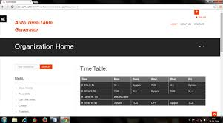

Figure 1.1. An interface of Auto time-table generator

**Online automated faculty timetable general application**

This is an online timetable generator designed to be used by organizations that need to schedule working time for their employees. It provides time-scheduling solutions to employers and gives accurate solutions. Since the target market for this system is not solely universities, it lacks a lot of features that will help universities schedule their timetable effectively and efficiently due to constraints and the increasing demands. Good software of this nature should be tailor-made to suit university work. Though the features available in this application make it good, it won’t serve the purpose of most universities.

**Automated college timetable generator**  
Most timetable generator programs use complex templates to create timetables, but the outcome does not look simple, they lose their simplicity. This system works with the simplest and most intuitive design that saves a lot of users’ time. This system uses a spreadsheet that is easy for beginner computer users to understand.  
  
A distinctive feature of this package is that there is no immediate demand for required information, but rather collects information immediately as you enter it. Information such as Number of teachers, names, subjects, etc. but one thing about this package is that it is only suitable for small schools and colleges. It cannot be used in big schools like universities with a large number of students, lecturers, faculties, etc.

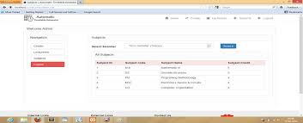

**Figure 1.2**

**2.4 CHAPTER SUMMARY**

In this chapter, we discussed the literature review of our research where we introduces the chapter, talked about the conceptual and the theoretical review of the research topic, review some existing systems about our proposed system and the final paragraph summarizes the whole chapter**.**

**CHAPTER THREE**

**(METHODOLOGY)**

**3.1 INTRODUCTION**

This chapter entails the detailing of the methodological approach used in the making of this project. The chapter is made up of nine subsections they are as follows:

**Research design approach.** This section discusses the approaches employed and the reasons for which those particular approaches were used. Methods used to investigate the problem as well as deduce the solution are also addressed. Approaches used for requirement elicitation and test results are also discussed in this section.

**Research setting.** This section discusses the setting in which the experiment is conducted, namely cultural, physical or social. Key aspects of the place relevant to the research are also discussed.

**Data collection instruments**. This section is about the use of the appropriate data collection instruments employed in attaining accurate and relevant data to aid the development of this project. These tools are thoroughly explained in this section.

**Ethical considerations.** Since this project work requires the collection and use of sensitive user data the requisite ethical considerations employed are discussed in this section. Measures employed to protect research subjects’ privacy confidentiality and even their health are also addressed.

**Description of the proposed system.** In this section, a succinct description of the proposed system is discussed.

**System development building.** This section is made up of two subsections these are

**Tools.** This is about the tools intended to be used to develop the chosen system. In this regard, the programming language used, database management system used, network simulation software used, web development framework or library used and the like are addressed in this section.

**Development process.** This section describes the particular system development process intended to be used for the development of the system and the rationale behind it. Each phase in the development process is discussed detailing exactly what was done.

**The System Development Life Cycle (SDLC).** This section describes each activity done under each phase in the SDLC. That is the planning, analysis, development, and implementation phases respectively.

**Chapter summary.** The chapter is summarized in this section.

**3.2 RESEARCH DESIGN**

Polit and Hungler (1999:155) describe the research design as a blueprint, or outline, for conducting

the study in such a way that maximum control will be exercised over factors that could interfere with

the validity of the research results. The research design is the researcher’s overall plan for

obtaining answers to the research questions guiding the study. Burns and Grove (2001:223) state

that designing a study helps researchers to plan and implement the study in a way that will help

them obtain the intended results, thus increasing the chances of obtaining information that could be

associated with the real situation.

A research design is a set of research methods and techniques that a researcher decides to use in his or her research. The chosen design allows researchers to improve their research methods related to their subject and to design the research successfully. There are two different types of research designs that one can choose from when doing research work. The choice of research design depends on the type of research one is undertaking. The examples of research designs are:

1. Quantitative Research Design
2. Qualitative Research Design

Quantitative research design is a type of research design where the research work is mainly based on variables where numbers and statistics are used to analyze the outcome. The data collection for measurement is in the form of pie charts, figures, and graphics, and this data is used to describe the information about the collected data.

Qualitative research design on the other hand is the direct opposite of the quantitative research design. Qualitative research design is theory-testing research where one seeks to find answers to questions like what and how a certain phenomenon occurs. It is explanatory in nature because the researcher draws conclusions based on the answers gotten from his findings.

In this our research on automated timetable generator, we seek to use the quantitative research design because our research deals with data manipulation to solve a problem. Also, our research is to identify behavior or occurrence and monitor it in its natural setting to solve the existing problem with the analyzed data.

Quantitative research design has four main methods that can be used in research design, thus:

There are many ways to group classify quantitative research design depending on the purpose of the research and the design approach been used. The following are the research design types:

* Experimental research design.
* Correlational research design.
* Diagnostic research design.
* Descriptive research design.

Among the above research design types, the most appropriate design type to use for our research is the diagnostic research design.

Diagnostic research is a type of research design type that aims to study the root cause of a specific problem or situation. This will give you an insight into the factors that lead to specific issues or difficulties that your customers may encounter. In this type of research design type, the researcher tries to assess the cause of a specific challenge. It also helps the researcher to realize more in detail the prime cause of a particular problem.

Timetable scheduling in the universities is tedious, frustrating, and above all time-consuming. These problems existed over the years without a solution. One aim of our research is to identify the causes of these challenges and find a long-lasting solution to them. The best research design type that can help us achieve this is the diagnostic research design.

Steps to undertake when using diagnostic research design type include:

Step 1: The inception of the problem. This step tries to find out when the problem arises and also in what condition the problem manifests more.

Step 2: Diagnosis of the issue. This step determines the base cause of the challenge. What factors are influencing the problem?

Step 3: Solution for the issue. What to use to cure or eradicate the issue. What actually worked in solving the problem?

Data collection method.

The quantitative research approach fundamentally requires data from respondents. The outcome of the research will represent what the respondents want. There are different ways to gather data in quantitative research for example:

* Survey.
* Experiment,
* Observation.
* Interview
* Longitudinal studies.
* Polls
* Face-to-face interviews
* Questionnaire.

For the purpose of this research, we shall use experiment and face-to-face interview data collection techniques.

The method with which one gathers data in quantitative research. Have a great bearing on the respondent’s responses.

The following are the reason for choosing Face-to-Face interview data collection:

* The researcher makes sure that the respondent is the targeted participant.
* The researcher has the ability to tune the interaction exactly how he wants it.
* The very vital and complex questions will be asked for further understanding.
* The researcher will be able to use a probe-type of questioning to elicit the right information from the respondent.

The use of experiment as a data collection technique allows the researcher to change some variables responsible for the problem and observe how they take effect on other variables. Experiment data collection also helps to explore the relationship between variables and it is also suitable in different fields such as medicine, agriculture, sociology, and psychology.

When data is collected there is a need to analyze this data. In the quantitative research approach, there are two ways to analyze data thus; statistical analysis and descriptive and inferential analysis. For this research, we decided to use descriptive and inferential analysis because it will allow us to draw a conclusion from the whole data collected.

Our main reason for choosing a quantitative research design is:

It is easy to analyze data

The conclusions are generalizable since the respondents are the targeted respondents.

**3.3 RESEARCH SETTING**

Research setting refers to the place the research work has taken place and also where data involved is collected. In this study, we intend to solve the timetable scheduling problem for the Akenteng Appiak-Menka University of Skill Training and Entrepreneurial Development (AAMUSTED). This University formerly was known as Coltek a satellite campus of the University of Education Winneba. It is situated in Tanoso a suburb of Kumasi in the Ashanti Region. The school is made up of thousands of students from all geographical locations in Ghana. This study which aims at coming out with an automated system for timetable scheduling is aimed at helping the academic office in the administrative department of AAMUSTED. Data collection is also going to be done right on the campus of AAMUSTED which will include students, lecturers, and the workers in the administrative department. Our main target for data collection and research work is the academic affairs in the administrative department of AAMUSTED.

The academic affairs of the administrative department of AAMUSTED is responsible for:

* Developing and evaluating strategic plans and mission statements.
* Reviewing proposals for new academic programs and revision of existing ones.
* Scheduling lecture timetables, duty timetables, and exam timetables.
* Establishing new academic organizations and structures.

**3.4 Data collection instruments**

Data collection is the process of collecting and measuring information about variables of interest in an established systematic way that allows research questions to be answered, hypotheses to be tested, and results to be evaluated. Data collection is essential in all fields of research work. Though the method of collecting data may vary, priority is always placed on the accuracy of the data collected in all fields. The prime goal for data collection is to gather quality evidence which will be analyzed into rich data which will be used to give credible answers to baffling questions.

The choice of data collection tool depends greatly on the type of research and the research design approach the researcher decides to do. There are numerous data collection instruments but for the purpose of this project, we shall use face-to-face interviews, and questionnaires to collect data.

Face-to-face data collection is the process of collecting data from respondents where the researcher or a trained interviewer uses a standardized interview protocol and a standardized set of responses. In a face-to-face interview, the interviewer meets the interviewee or the respondents directly for interactions in order to collect accurate data. We choose to use this data collection tool due to the following reasons:

* It gives the researcher the ability to control the interaction
* It ensures that the targeted participant is the respondent
* It allows the researcher to use probe questions in eliciting information from the respondent
* It also gives room for the researcher to ask relevant and complex questions.

One other data collection tool we shall use is the Questionnaire. A questionnaire is a list of questions prepared for respondents to answer with the aim of collecting data pertaining to a specific field of study. In designing a questionnaire for research, the questions must be valid and reliable so as to address the research objectives. The questions must be placed in the right order so as not to confuse the respondent. Using questionnaires in this research work will allow us to:

* Reach a lot of stakeholders quickly.
* Save us a lot of time.
* Give our respondents the flexibility to respond to questions.
* It will also help us gather accurate data.

The questionnaires will purposely be designed for students to seek their views on the challenges lecture timetables pose to them in a semester. With this in mind, we shall use google forms and survey monkey to prepare the questionnaires so that the students can feel comfortable answering them for quick response.

**3.5 ETHICAL CONSIDERATION**

Before answering the question of what ethical software development should and cannot do, it is important to determine the scope, and limits of the ethical considerations that software engineers and their groups can implement. Many of the issues that appear to be a result of software development and its usage are in fact the result of specific business models and key political, legal, and cultural circumstances. It is vital that any developer have this in mind before embarking on software development. The kind of data needed for the system to be completed is not sensitive and needs not to be protected since the right data to be used by the system will be entered by the authorized officer. The team ensures that there will be administrative-level logging in the system where only authorized personnel will be allowed to enter data into the system. The logging is also meant to prevent unauthorized users who will like to use the system for their own gain from trying to get access to the system.

**3.6 DESCRIPTION OF THE SYSTEM**

Our proposed system which shall be called AAMUSTED Timetable Scheduler (ATS), is an automated system that shall receive data from the user into a database. Based on the data collected, the user enforces some constraints that are already built into the system. The system verifies the constraints, collects data from the database, and uses an algorithm to generate a timetable. The system upon generating a timetable checks if all rules for each constraint are enforced and if not, the system prompts the user to make the necessary corrections. The system regenerates the timetable. After timetable generation, the system allows the user to print out the generated timetable, and a copy of the timetable will be sent to course reps and lecturers through an email or WhatsApp.

Below is the system architecture of our proposed system which further describes the entire system.

**3.7 SYSTEM DEVELOPMENT /BUILDING**

**3.7.1 Tools**

The proposed system (AAMUSTED Timetable Scheduler) is a stand-alone application that can run on all personal computers with the Windows operating system. The system is going to be developed using C# as the programming language. We choose to use C# because of the following reasons:

* It provides a faster development time.
* It is highly scalable which means the program is reliable and allows changes to be made to suit a specific idea.
* It is object-oriented
* It has a big community of users of the language

The system needs to keep relational data which the system can manipulate to generate the timetable hence we shall use a database management system called MongoDB in structuring the data. There are lots of database management systems to choose from but we decided to use MongoDB because of the following reasons:

* It has a flexible document schema
* It is widely supported by many languages
* It is built to provide powerful querying and analytics
* It is simple to install
* It is cost-Effective

**3.7.2 Software development process**

A software development process is a process of dividing software development projects into simpler or sequential steps or processes to improve the design. There are different types of software development processes that one can choose from depending on the type of project and the resources available to the developing team. Our proposed system shall be developed using the Agile Development model.

Agile model in the software development model is a type of software development process where the system is built incrementally through iterations so as to accommodate any changes that may be necessary for the full functioning of the system. In the agile model, the requirements for the system are broken down into simpler stages that can be developed and used. In a nutshell, the agile model is a combination of iterative and incremental process models. It aims to customize processes and satisfy customers by delivering fast-running software.

Why do we choose the agile software development model for our proposed system?

* The agile model will help the team establish close contact with the users of the system so as to gain a clearer understanding of the various requirements.
* The software needs to be deployed for use as quickly as possible, doing comprehensive documentation before designing the system as it is in other models will delay the process.
* Requirements for the system may change alongside the development of the system therefore there is the need to choose a development model that accommodates changes for effective and efficient system development.
* This project is a final year undergraduate project and the team is made up of only four members hence there is the need to choose a software development model that good with a small number of team members.
* The agile model in software development deploys what is called pair programming thus whiles one person is doing the coding, the other person reviews the code as it is being typed. This will reduce development time and also have fewer errors in the code.

The agile software model consists of 5 major stages these stages are:

Planning

Analysis

Design

Coding and Unit testing

Acceptance Testing.

**3.8 SYSTEM DEVELOPMENT LIFE CYCLE (SDLC)**

Software development does not go through a single stage or phase to come out with software, it contains a series of stages or processes and this is known as the system development life cycle. Software development life cycle is a business practice adopted by software engineers in building software applications. This practice is divided into stages or faces with each phase having a specific task to be performed. The stages differ a little bit depending on the software engineer involved or the kind of software being built but the major phase includes:

* Planning phase
* Analysis phase
* Design phase
* Implementation phase.

**3.8.1 Planning phase.**

The planning phase is the first phase in a software development life cycle. At this stage, the project team evaluates the project. This is done by setting goals and objectives, creating the team and leadership structure, creating timetables to schedule tasks, and calculating cost and labor. Planning clearly defines the scope and the purpose of the project.

The team having these in mind first of all visited the academic department of Akenteng Appiah-Menka University of Skilled and Entrepreneurial Development for feedback on the purpose of the system to enable us to plan the project. The team sat down together to set goals and objectives for the project. The team leader was selected and a task is giving to each member. The team leader clearly specifies each member’s task to him and resources to be used were shared for the commencement of the project.

**3.8.2 Analysis phase.**

This is the second phase of the software development life cycle. At this stage, requirements for the system are defined. Requirement analysis is considered the most important and fundamental stage in the software development life cycle. It involves defining the resources, the constraints, and the variables needed for the system to be built. This is done with much caution and accuracy as whatever is gathered as a requirement has both positive and negative bearing on the success of the system. The analysis phase also gathers business requirements and identifies risks. This phase of the SDLC also includes a feasibility study that identifies all the strengths and weaknesses of the project to assess its overall viability of the project.

At this phase, the team went to the academic office for the second time for a face-to-face interview with the employee responsible for scheduling the timetable for the university. The team in the first place designed the interview questions before going to the office. The team secretary recorded on paper all the answers given by the officer in charge of scheduling the timetables. In addition, google forms were used by the team to create questionnaires and distributed only to some course reps of the university. The collected data was evaluated and a requirement document was prepared for the design phase.

**3.8.3 Design phase**

This phase is made up of High-Level Design and Low-level Design. High-level Design is where the team designs the various components of the system focusing on the various models that come together to make the overall system design. High-level Design is developed first in a sequential manner. It turns the collected requirements into high-level solutions.

Low-level Design is like putting the High-level Design into a visible system. Low-level Design is when the designer focuses on the components of the High-level Design.

Below are the various components of the High-level system Design:

Student’s Classes

Lecture Rooms

Courses

Lecturers

Create Year

Create Semester

Rules/Constrains

Verification

Timetable Generation

Review

Edit

Regeneration

Timetable

Printing

Preview

Admin Login

Create Admin

*Figure: (3.1) general overview*

***General system overview***

Admin Login

Display Main Page

If Authentication Invalid

Admin Validated

Insert all required data (Courses, Classrooms, Classes, Lecturers)

Apply all active rules for each constrains

Extract Timetable report using Genetic Algorithm

*Figure: (3.2)* ***System flowchart diagram***

Failure

Success

Re-extract Timetable report using Genetic Algorithm

Extract Timetable report using Genetic Algorithm

Apply all active rules for each constrains

Print Timetable

Admin Logout

Admin Login

Display Error Message

Insert all required data (Courses, Classrooms, Classes, Lecturers)

Make all necessary changes to data that needs to be changed

Reenter all required data in correct format

Edit Existing Timetable

Valid Entries

Invalid Entries

Valid Entries

Invalid Entries

New Timetable

*Figure: (3.3)****. System Activity diagram***

Login Page

(ID & Password)

Home Page

Insert all required data (Courses, Classrooms, Classes, Lecturers)

Apply all active rules for each constrains

Extract Timetable report using Genetic Algorithm

Print Timetable

Insert data into database

Admin Logout

*Figure: (3.4).* ***High-level system Architecture diagram***



**ADMIN**



**SYSTEM**

*Figure: (3.5)****. System Use case diagram***

Access stored data

Generate timetable

Specify constrains

Validation conforms

Check for validation

**ADMIN**



AAMUSTED TITMETABLE SCHEDULER

DATEBASE

Admin Login

Enter required data

Verify and store data

Print timetable

Store generated timetable

Access stored timetable

*Figure: (3.6).* ***System sequence diagram***

**Admin Login**

-username: string

-password: string

**+Login ()**

**Home Page**

**+SelectOption ()**

**Sign out**

**+autoSaveChanges ()**

**+signOut ()**

**View Timetable**

-year: int

-semester: int

**+viewByClass ()**

**+viewByDepartment ()**

**+viewAll**

**+printTimetable ()**

**Edit Timetable**

-year: int

-semester: int

**+editData ()**

**Data Page**

**+selectData ()**

**New Timetable**

-year: int

-semester: int

**+getClassData ()**

**+getRoomsData ()**

**+getCoursesData ()**

**+getLecturersData ()**

**+specifyConstrains ()**

**+createTimetable ()**

**Classes Data**

-class_id: string

-class_name: string

-class_size: int

-hasDisability: Boolean

-courses: array

**+saveClasses ()**

**Courses Data**

-course_code: string

-course_title: string

-lecturer: string

-credit_hourse: int

-special_Venue: string

**+saveCourses ()**

**Rooms Data**

-room_id: string

-room_name: string

-room_capacity: int

-forDisability: Boolean

**+saveRooms ()**

**Generate Timetable**

**+getClassData ()**

**+getRoomsData ()**

**+getCoursesData ()**

**+getLecturersData ()**

**+specifyContrains ()**

**+reCreateTimetable ()**

**Lecturers Data**

-lect_id: string

-lect_name: string

-couse: string

-exception_day: string

**+saveLecturer ()**

*Figure: (3.7)****. System class diagram***

**ADMIN**

-username: string

-password: string

**CLASS DATA**

-class_id: string

-class_name: string

-class_size: int

-hasDisability: Boolean

-courses: array

**COURSE DATA**

-course_code: string

-course_title: string

-lecturer: string

-credit_hourse: int

-special_Venue: string

**LECTURER DATA**

-lect_id: string

-lect_name: string

-course: string

-except_day: string

**ROOM DATA**

-room_id: string

-room_name: string

-room_capacity: int

-forDisability: Boolean

**LOGIN**

-login_id: string

-login_pass: string

*Figure: (3.8).* ***System E-R diagram***

**3.8.4 Implementation**

This is the phase where the team begins to develop the actual system using the inputs done in the design phase. At this stage, the team leader instructs the one responsible for writing the codes to start writing the code and one other person reads and reviews the codes for error corrections. Other members of the team are made to document the functions of the system and the user guides. The tools to be used at this stage are:

Microsoft Visual studio. Microsoft Visual Studio is an Integrated Development Environment (IDE) that can be used to develop computer programs. The team decided to use Microsoft visual studio because of its support for a lot of open-source programming languages. The team decided to use C# as the programming language and it is supported by Microsoft visual studio.

MongoDB. This is a database management system that will be used to keep data for the system. The team decided to employ to use this technology due to its robustness, its flexible document schema, and also support multi programming languages including the language the team decided to use.

3.9 **SUMMARY.**

In this chapter, we further discussed the methodology we used in our study and also in our development process. Under this chapter we made provisions for some ER Diagrams of the proposed system. Tools, programming language and all the technologies used for the system.

**CHAPTER FOUR**

**4.1 Introduction**

In the previous chapter which is chapter three, we gave details about the methodology to use in our system design. We gave details about our design processes and the various stages to undergo under the system development life cycle. In this chapter (4), we are going to talk about the system demonstration and evaluation. Software development undergoes different stages to get the software fully implemented. Demonstration and Evaluation are one of the stages to undergo before a system is fully implemented for use. In this chapter, we shall give details about how our system is going to be experimented. It will involve the various experimental tools and platforms that we shall use to demonstrate how the system is going to function. We shall also talk about the software and hardware requirements of the system and also give details on the configuration of the simulation tools that we shall use in experimenting with the various functions of the system and give details of how this experiment was conducted.

In this same chapter, we shall describe how the team conducted system testing, integration testing, acceptance testing, and the methodology used in the testing processes. The chapter will also include screenshots of the key system interfaces and how they work. We shall provide the data used in testing the robustness of the system. The chapter will be concluded with a chapter summary.

**4.2 SYSTEM DEMONSTRATION.**

System demonstration is a stage under Software Development Life Cycle. It is the method of reviewing the current state of a system and gathering immediate feedback from the development team and the various stakeholders. System demonstration provides room for the Software development team to show stakeholders the integrated view of the system features as development is ongoing. The main aim of this system demonstration is to learn about the progress from the development and adjust any course of action that may be identified.

**4.2.1 Experiment/Simulation Setup**

Software simulation is the process of modeling the real operations or functions of a system using various simulation tools. Simulation is done with both hardware systems and software systems and since our project is a software application, we shall use the software simulation. By this we shall use software simulating tools to imitating the real-world operation of our system to users showing how the software operates or functions. The use of software simulation to demonstrate the functions of our system will give the users of the system an experience to feel as if they are actually using the system.

Software simulation is mostly done with professional screencasting tools and eLearning authoring tools. There are lots of these software simulation tools available to us to use but for the purpose of this project, we shall employ to use adobe captivate for our software simulation.

Adobe Captivate is a smart authoring tool that gives its users the ability to create all kinds of responsive multimedia content without employing the use of programming. Adobe captivate is available for Windows and MacOS platforms. It contains pre-programmed tools that help the user to create content such as software demonstration and software simulation. It also helps organizations train their employees and partners on the use of systems.

In choosing a particular software simulation tool, there is the need to evaluate the tool using these four criteria. These criteria are:

1. Quality of Training
2. Maintainability
3. Scalability
4. Content delivery time

The quality of training as a criterion in choosing the above-mentioned simulation tools has to do with how interactive the simulation is. The created simulation should allow learners to use the simulation just like the actual software. Users of the simulation created by the tool should not notice any difference. This will retain what they learn from the simulation and real-world performance of the system.

Maintainability is the second criterion in choosing the simulation tools means the simulation tools must withstand the future changes or additions that may occur in the system life cycle. It should be flexible to include these changes for users to be able to use the simulation to update their knowledge of the new features of the system. The tool must be capable of creating software simulations for all kinds of systems. It should also be able to simulate different kinds of scenarios for different users.

The third criterion is Scalability. A software simulation tool is said to be scalable if it can handle a large number of trainees and is also consistent in providing adequate and appropriate data. Therefore any software simulation tool that we shall use must be scalable.

When we talk about the content delivery time as a criterion in selecting a software simulation tool, it means the tool must be responsive, quick to create and update simulation content, and quick to deploy. Due to the fast demand in software deployment to manage businesses, a simulation tool must offer high-quality output on time.

Critically considering the above criteria in choosing a software simulation tool, we realized adobe captivate will be the best tools to use in experimenting/simulation of our system.

**4.2.2 Experimentation/Simulation**

A simulation content was created by the team using adobe captivate. The simulation was then administered to the Management Information System Officer in charge of creating a timetable for AAMUTED. When the simulation was administered, we asked the officer to provide the team with feedback on the following:

1. The user interface.
2. The System Responsiveness.
3. Issues that needed improvement.
4. Problems that may prevent the system from functioning.
5. Things that could lead to system improvement.

After the administration of the simulation, the team went back for the feedback from the officer and the necessary adjustments and improvements were made.

**4.3 System Evaluation**

System testing is one of the phases in software life cycle where the software team evaluates and validates the various components of a software together in full to see how it will behave after component integration. Here all the software components are integrated and tested together to ascertain its validity. This kind of system testing is mostly done by Quality Assurance team. Software testing follows series of different types of testing. These series of testing is done in a hierarchical manner. The first part of system testing is unit testing which is normally done by the one who writes the code. Followed by Integration testing which is done before, during, and after a new model has been integrate into the software package. System testing is next after integration testing, this testing is mostly done by an agent which is recognized as well vested in software. The test is conducted on the complete software package before introduced to users. Acceptance testing which is done by the real users of the system is the conducted after system testing. The reason and the need for this system testing is to identify any bugs in the software and fix them early before the software is delivered. Also for ensuring quality of software for users, there is the need for system testing. This will help the developers to know whether the software is compatible with other types of devices on which the software will be used. The main objective of every system is to give satisfaction to its customers hence it is necessary to conduct system testing which will provide prerequisite and perfect user experience.

In summary, system testing is done to verify and validate if a software system meets all its requirements. These requirements includes technical, business, and functional requirements. These can be achieved by using some variety of test types, including performance, usability, load testing and functional testing.

In an attempt by the teams to conduct system testing, we went through the following types of testing, unit testing, integration testing, and acceptance testing. In the next paragraphs, we shall describe how the team conducted the various testing mentioned above.

**Unit testing** also called component testing is a type of software testing which is the first from the bottom of the system testing hierarchy. It is a kind of testing in which the various models that make up the entire software system is tested individually. This is done to be sure what the particular unit is meant to do is what it is actually doing. The unit testing is performed on a standalone module to check whether it is developed correctly.

One of the functional components of our proposed system “AAMUSTED Timetable Generator” is the user must be able to login into the system to be able to use the system. So after writing that section of the code to log in, the team run the code and tested by feeding login credentials to see if really a user can login to the system with secrete credentials. Other members of the team also created logins with their secrete credentials so as to check if they can login. The same was done for all the models that make up the system. Unit testing could done manually and automated but the team conducted the test using manual testing mode with real user data and step-by-step instructional document.

The reason for conducting unit testing is for us as developers is to help us identify and fix bugs, and “if proper unit testing is done at the early stages of development, then it saves time and money at the end”. The team defiled the “unit testing myth:” which states “it requires time, and l am always overscheduled” and “My code is rock solid! I do not need unit testing” to test all models.

**Integration testing** is also one type of software testing where all the various models that made up the software are integrated and tested together. This I to make sure that all the models are working seamlessly with each other as it is supposed to. During integration testing, the testing will expose any kind of defect that may arise from the interactions between the models. Our purpose in doing integration testing is to focus on checking how data is communicated among the models. All though all the models are tested during the unit testing, defects may still occur when the models are integrated and there are lots of factors that can cause these defects. In integration testing, there are many approaches that one can use but among them, we chose to use incremental testing. This is because the algorithms that we used in each model have a lot of decision structures and using the Big Bang testing will not be convenient. The Incremental approach testing will allow us to integrate two or more models and test them together.

The team conducted integration testing using test cases. Below is the sample integration test case. The software has different models so in the test case, we use the following models: ‘Login page’, ‘import Excel file’, ‘Settings’, and ‘generate tables. All these three models have been integrated logically.

Here we are going to check if a user logs in successfully he can upload data from an excel file, and create configurations that will enable him to generate a successful timetable.

**Test case used in the Integration Testing.**

|  |  |  |  |
| --- | --- | --- | --- |
| **Test Case ID** | **Test Case Objective** | **Test Case Description** | **Expected Result** |
| 1 | Check the interface between the login model and the Import Excel file model. | Enter Admin login credentials and click on the login | To be directed to the main page to locate the import Excel file. |
| 2 | Check the communication between imported and saved to enable configuration settings | Select the appropriate excel file, select the particular department it is coming from and click on ‘Save file ‘button. | The user receives a “file uploaded successfully” message and when the user clicks on the settings button it opens the configuration page. |
|  | Check the communication between the Settings model and Generate table model. | Enter all necessary configurations and click on ‘save configuration’ button. | Generated timetable should appear on the Tables interface. |

*Table (4.1)*

The above test case shows how we conducted the integration testing. This was carefully planned by the entire team, the test case was designed and executed. We also used the IDE console message in tracking any defects and this process was repeated till the desired result was achieved.

**Acceptance testing** is also called User Acceptance Testing. It is the final testing done on software before it gets into the production stage. Acceptance testing is done by the end users of a system. Every software will finally be used by people after production and it is necessary to allow the users of the system to also test it before production. Acceptance testing is a kind of testing done by end users to verify and accept the software. There is the need for acceptance testing once the software has undergone unit testing, integration, and system testing because the software was mainly built on our own understanding of the requirements document received before the design and development stage. Any further changes were not effectively communicated during the design and development stage. So testing whether the software is accepted by the clients and end users is important.

The acceptance testing was done in two major folds thus alpha testing and Beta testing.

The alpha testing of our system is done by ourselves, the client in the person of Our Supervisor and, the Academic department responsible for creating timetables for the school. The integrated models of the software are sent to our supervisor and the one in charge of timetables to test. The team outlined the following task for the acceptance testing:

* Analysis of business requirements (stating the purpose of the software)
* Drawing test plan (how the testing is to be conducted)
* Identifying test cases (what end user should be testing for?)
* Preparation of test data (what kind of data to be used for the testing)
* Run and record test results (executing the test cases and reporting bugs if any)
* Confirm business objectives (specify whether the business requirements of the system are met on not)

In the beta testing, the compiled version of the software was installed on the academic officer in charge of the timetable’s computer where he works. He was allowed to use the software for a few days and give feedback.

The above are the tasks outlined for testers to follow for the Acceptance testing and the feedback from the testing is collected and analyzed. Whatever changes needed were made.

There are methodologies used in testing software, the team used the black-box methodology to test our system. Black-box testing is a testing methodology that hides the internal workings of a system from the tester. It is a high-level testing methodology and it mainly focuses on the behavior of the software and is done by the end users of the system. The project team used the black-box approach by considering the following:

It hides the real workings of the software from the one testing

Testers do not require technical knowledge, programming, or IT skills.

It focuses mainly on output.

Using the black-box approach to evaluate our system was based on functional and non-functional system testing.

**Functional Testing.**

|  |  |  |
| --- | --- | --- |
| **TEST** | **ACTIVITY** | **RESULT** |
| Login | Enter login credentials | successful |
| Export Excel file format | Click on the ‘Export file’ button to generate excel files for data collection | successful |
| Import data from an Excel sheet | Click on the ‘Import file’ button to upload data from an excel sheet. | successful |
| configuration | Check checkboxes and select the necessary combo-box items and click on the ‘save configuration’ button. | successful |
| Generate timetable | Click the ‘Generate Table’ button to generate a Timetable. | successful |
| Edit uploaded data | Click on the ‘Edit’ button by the data to edit and click on the ‘update’ button. | successful |
| Delete data | Click on the ‘Delete’ button by the data to delete. | successful |

*Table (4.2)*

**Non-functional testing.**

|  |  |  |
| --- | --- | --- |
| **TEST** | **ACTIVITY** | **RESULT** |
| Data protected | Database secured from unauthorized access through a user account. | successful |
| Robust | The system successfully could work as expected | successful |
| Scalable | The system could function properly with an increase in classes, venues, and courses | successful |
| User friendly | The interface of the system easy to use by all users | successful |

*Table (4.3)*

**Screenshots of key system operations**

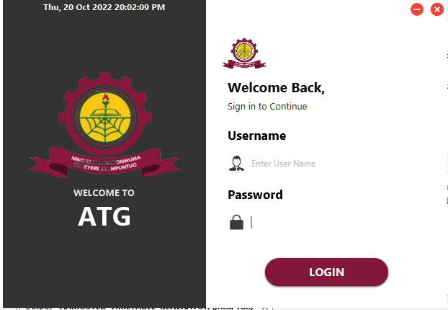

*Figure 4.1*

The figure above is the login page of the system. Due to system security and ethical issues concerning data, the system has a login page where the admin must set up a user account and for which he alone can use to access the system.

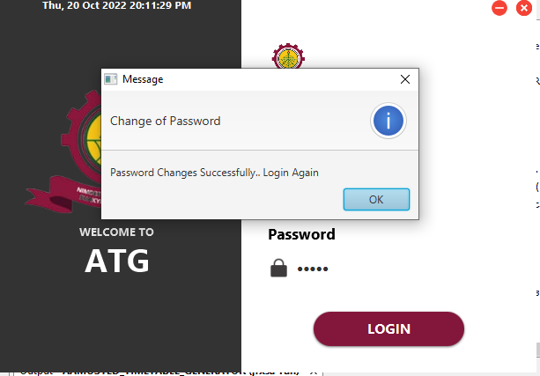

*Figure 4.2*

The figure above shows a successful creation of user name and password.

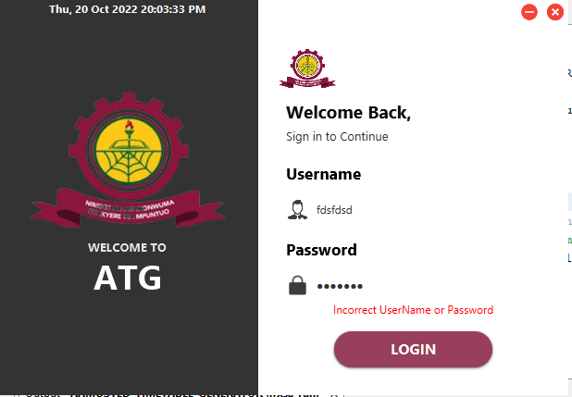

*Figure 4.3*

To test the robustness of the system, an incorrect user name and password was used to see if the system will allow any user to login. With this, there is an error message indicating incorrect user name or password.

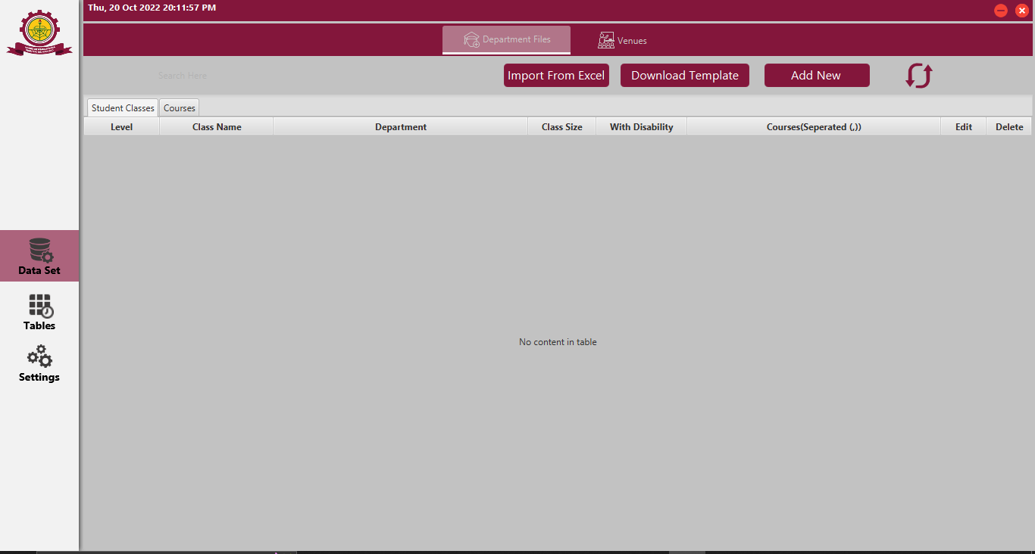

*Figure 4.4*

The figure above shows the homepage of the system where the user can navigate to other pages.

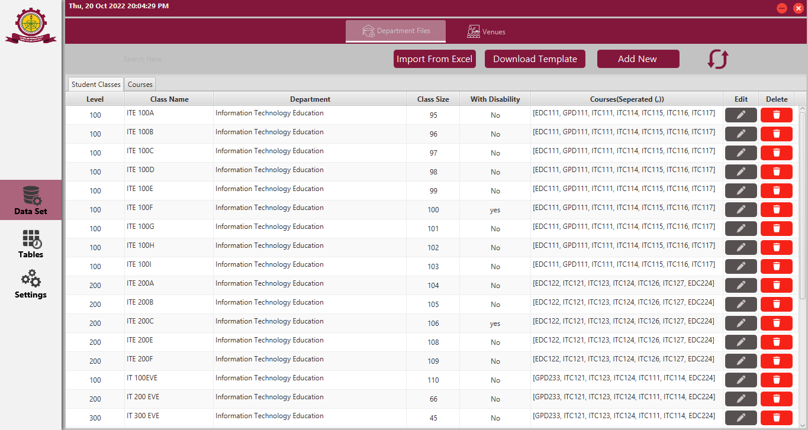

*Figure 4.5*

The figure above shows the data page. The data for generating the timetable must first be uploaded into a database first. And when uploading is successful, this page looks as it is.

To test the robustness of the system we shall try uploading wrong data and the right data to see if the system will accept any kind of data at all.

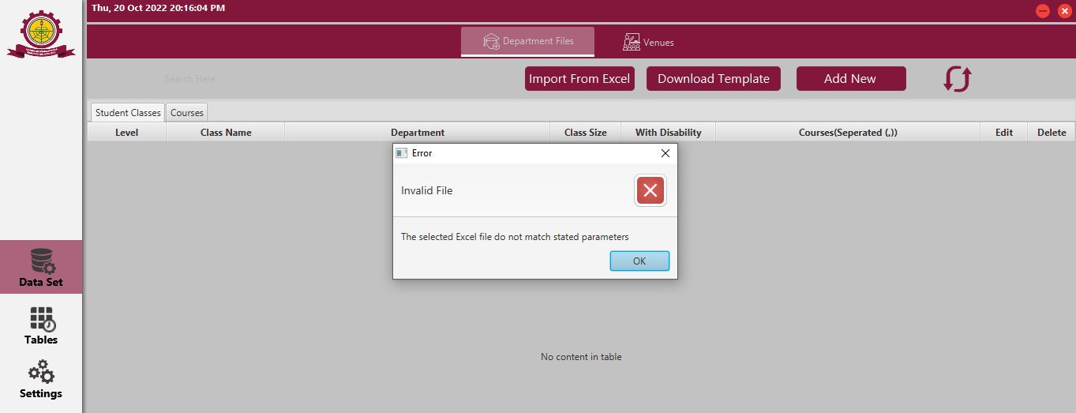

*Figure 4.6*

The figure above shows what happens when a user try uploading the wrong data.

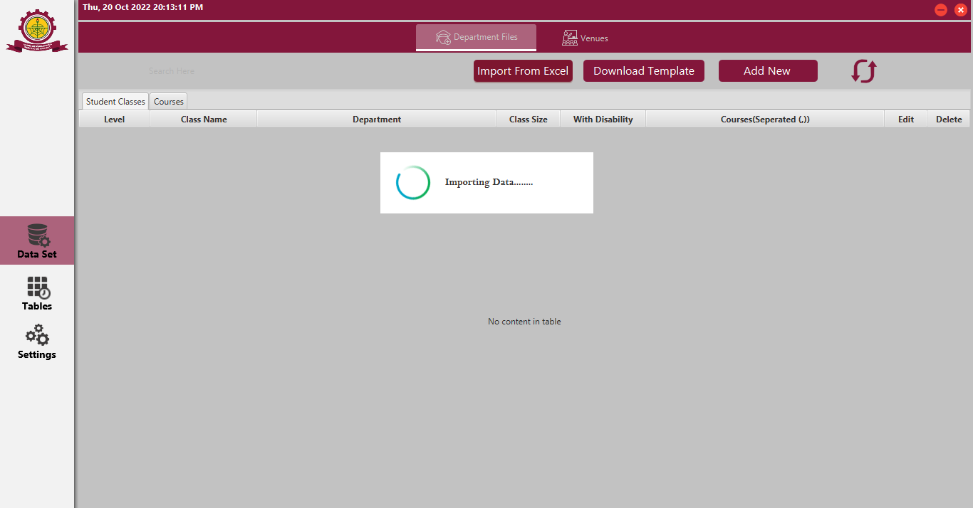

*Figure 4.7*

The figure above shows what happens when the right data is being uploaded.

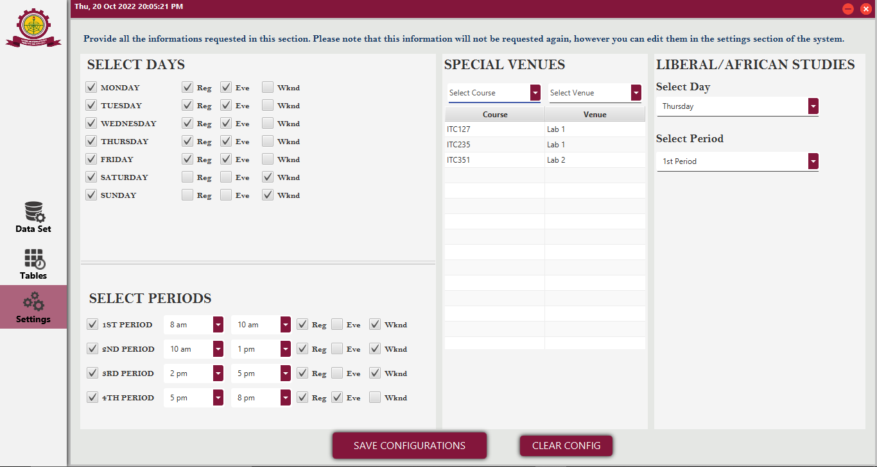

*Figure 4.8*

The figure above shows the settings page where the necessary stings are done before generating a successful timetable.

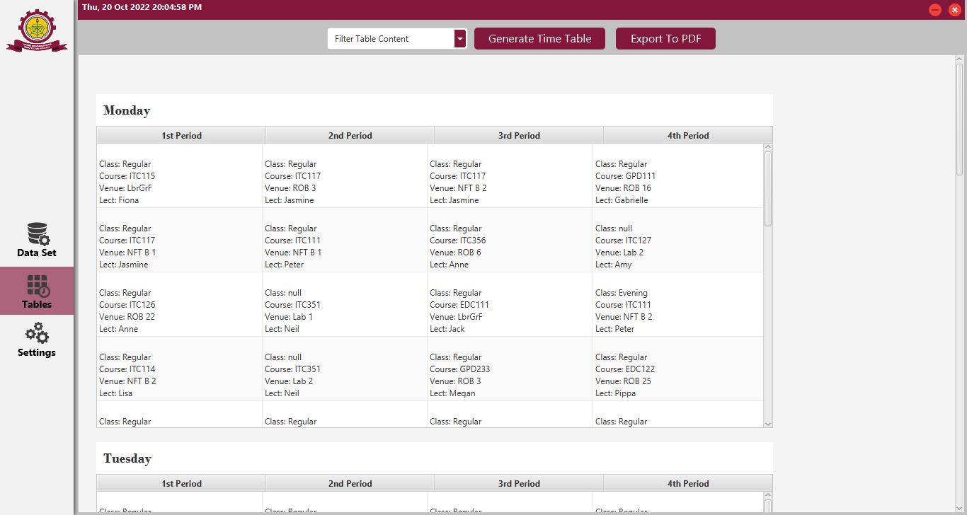

*Figure 4.9*

The figure above shows a successful generated timetable.

**4.4 Summary**

This chapter threw more light on system demonstration and evaluation. The chapter was briefly introduced. The chapter talked about system demonstration where it describes the simulation tools and the platform in which these tools are employed and the reasons for choosing them, it also Described the minimum software and hardware requirements of the system. Given details on the configuration of the simulation environment. The chapter also briefly narrate how the experiments were carried out from beginning to end. Later in the chapter, there was a description about how the team conducted unit testing, system testing, integration testing, and acceptance testing (alpha and beta tests). It explained the testing methodology the team adopted and why it was chosen. The later part of the chapter contain screenshots of key system operations, and their description.

**CHAPTER 5**

**5.1 Introduction**

This is the final chapter of the project it contains a quick summary of what the entire system is about. This chapter also will contain the Conclusion of the entire project where we shall describe whether the set objectives of the project have been achieved or otherwise. In The later part of the chapter, we shall talk about the recommendations thus to whom or institution that the team thinks the system should be implemented and the functionalities that should be added to make the system better. The chapter shall also be concluded by summarizing the chapter.

**5.2 Summary**

The project focus on designing a timetable generating system for AAMUSTED. It has become necessary due to the manual system used in scheduling timetables which is time consuming and full of defects. The timetable generator was to solve the above challenges. The system design to solve the problem was a standalone desktop application that could be easily used for scheduling timetables. The system objectives was successful, after a successful test of the system, the application could upload files into a database which were used in generating the timetable.

The tools used in developing this system were Java NetBeans and MongoDB. The testing of the system was successful as it generated a timetable which could be used to run the school.

**5.3 Conclusion**

The system was successfully designed and tested, and it was observed that all the projected objectives have been fulfilled. It was important to develop this system due to the evidence that it could be used to generate timetables without courses crushing. This system helped to solve the problems of time wasting and ineffective course scheduling. It is now easy for the academic staff responsible for scheduling timetables to generate an effective timetable within few seconds with a press of a button.

**5.4 Recommendations**

This system was designed purposely to be used in Akenten Appiah-Menka University of Skills Training and Entrepreneurial Development. Looking at the various faculties and their respective departments and the venues for lectures, the system was developed to suit these criteria stated above.

The current system generates timetables for the various types of students, save the timetables, export it in a PDF format and Print out a timetable. In the near future we will like to add e-mail services where the generated timetables can be sent to the respective course reps and lecturers. The system is scalable hence can withstand any upgrade and integration anytime.

**5.5 Summary**

The chapter five of this study talks briefly about the summary of the entire research work, the conclusion which described whether the set objectives of the project have been achieved or otherwise. The chapter also threw light on the recommendation of the study by stating the institution that the the system should be implemented and the functionalities that should be added to make the system better.

**REFERENCES**

1. Jumoke Soyemi, John Akinode, Sampson Oloruntoba Dept. of Computer Science Federal Polytechnic. Ilaro (August 5, 2017). Automated Lecture Time-tabling system for Tertiary Institutions. Retrieved March 17, 2022, from <https://www.researchgate.net/publication/318990161>
2. Wren (1995) A language for specifying complete timetabling problems. Retrieved March 18, 2022, from <https://web.fe.up.pt>.
3. Ben Moreland, Director of Education space Consultancy (April 21, 2015). Hard and Soft constraints – not only a working timetable but a great timetable. Retrieved March 18, 2022, from educationspaceconsultancy.com.
4. Hamed Babei, Jabaer Karimpour, Amin Hadidi – Computers and Industrial Engineering 86, 43-59. (2015). A survey of approaches for university timetabling problem.
5. Diary of a Headteacher (June 21st. 2017). Creating a perfect timetable is a challenge as we must balance the competing needs of students, teachers, and subjects. Retrieved March 18, 2022, from www.sec-ed.co.uk.
6. MC Chen, SL Goh, [NR Sabar](https://scholar.google.com/citations?user=0yWrqXAAAAAJ&hl=en&oi=sra), [G Kendall](https://scholar.google.com/citations?user=VjJm3zYAAAAJ&hl=en&oi=sra) - IEEE Access (2021). A Survey of University Course Timetabling Problem: Perspectives, Trends, and Opportunities. Retrieved March 19, 2022, from <https://ieeexplore.ieee.org>.
7. [SC Kong](https://scholar.google.com/citations?user=en_UO4EAAAAJ&hl=en&oi=sra), LF Kwok - Knowledge-Based Systems, (1999). A conceptual model of knowledge-based time-tabling system. Retrieved May 20, 2022, from schorla.google.com.
8. Mohd. Dain, A. A., Shaari, N. S. Gom, Y. S. & Bacheck, Z. A., (2001). General timetabling system for school. Retrieved May 22, 2022, from [www.academia.edu](http://www.academia.edu).
9. Berger, J. & Barkaouia, M. (2004) [A parallel hybrid genetic algorithm for the vehicle routing problem with time windows](https://www.sciencedirect.com/science/article/pii/S0305054803001631). Retrieved May 22, 2022 from schorla.google.ca
10. Causmaecker, P. D., Demeester, P. & Vanden B. G., (2002). Timetabling for schools. Retrieved May 25, 2022 from schorlar.google.com
11. Yingsong, z. & kiyooka, s., (1999). General timetabling system for school. Retrieved May 25, 2022 from schorlar.google.com
12. Tzafestas, S. G. (1999). Genetic algorithm. Retrieved May 15, 2022 from schorlar.google.com
13. Chimmiri Venkateswarlu (November 2020). A Metaheuristic Tabu Search Optimization Algorithm: Applications to Chemical and Environmental Processes. Retrieved May 27, 2022 from <https://www.intechopen.com/online-first/77046>.
14. Polit and Hungler (1999:155). Research methodology. Retrieved May 28, 2022, from <https://docplayer.net/20948754-Chapter-3-research-methodology.html>

APPENDICES

1. Sample codes of the system.

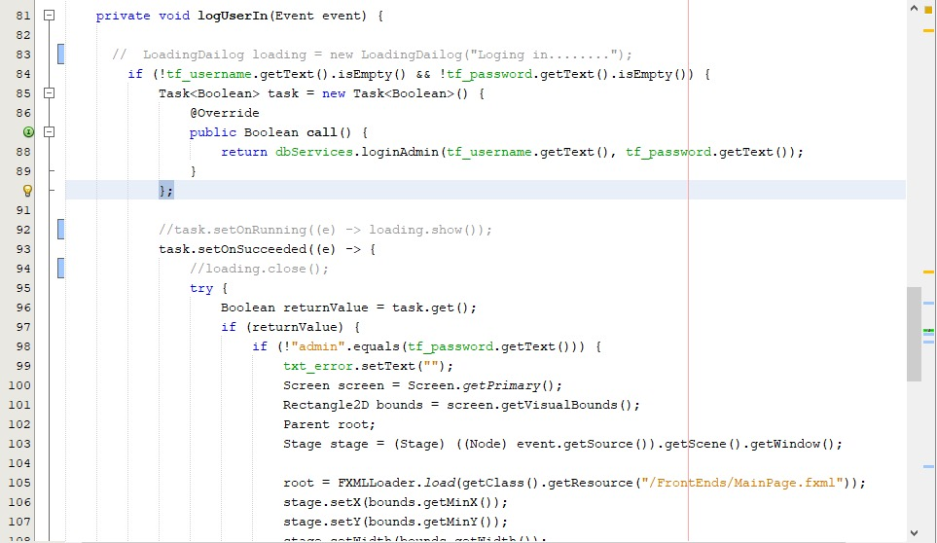

The above code snippet handles user login.

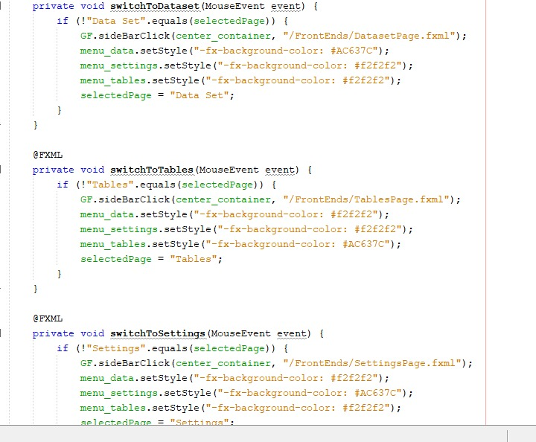

The above code snippet handles the various models selections.

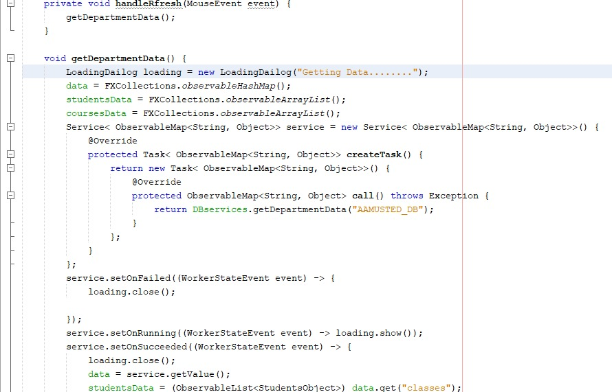

The above code snippet is for uploading data from various departments into the system’s database.

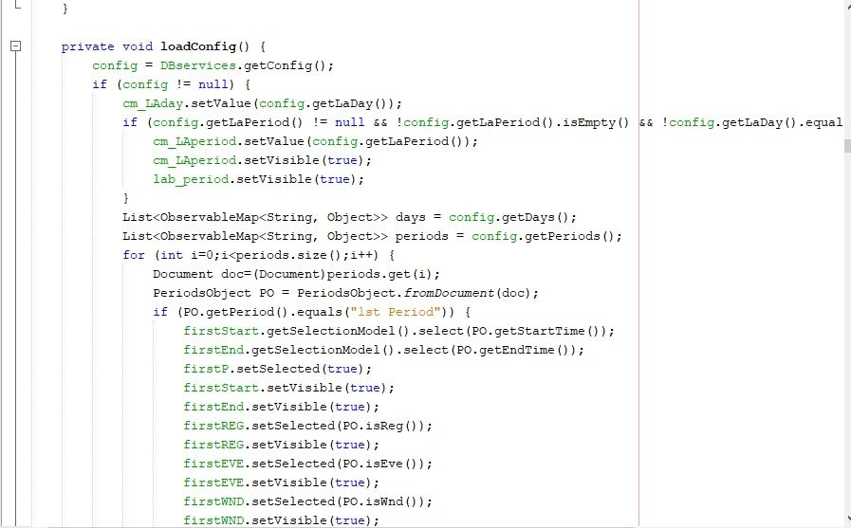

This code snippet is for configuration setup and timetable generating.